1. Add two numbers:

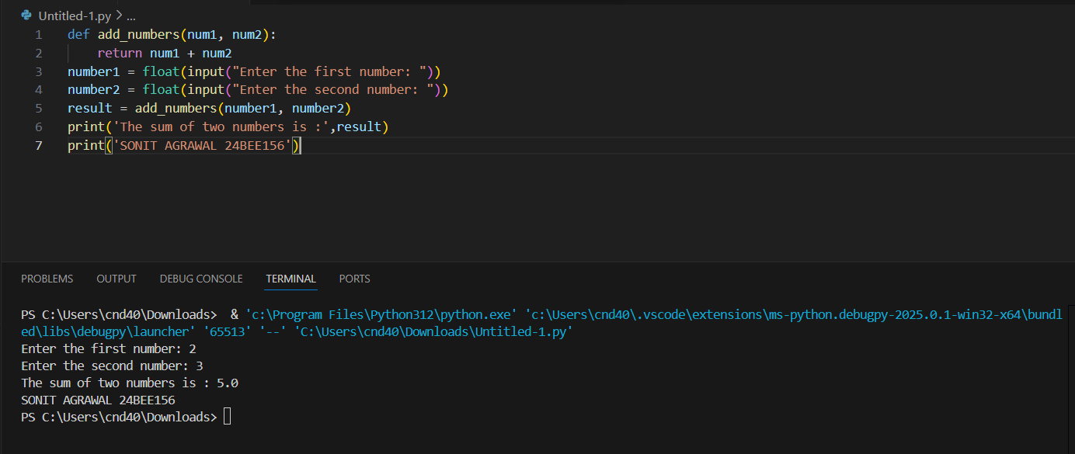

1. Subtract two numbers:

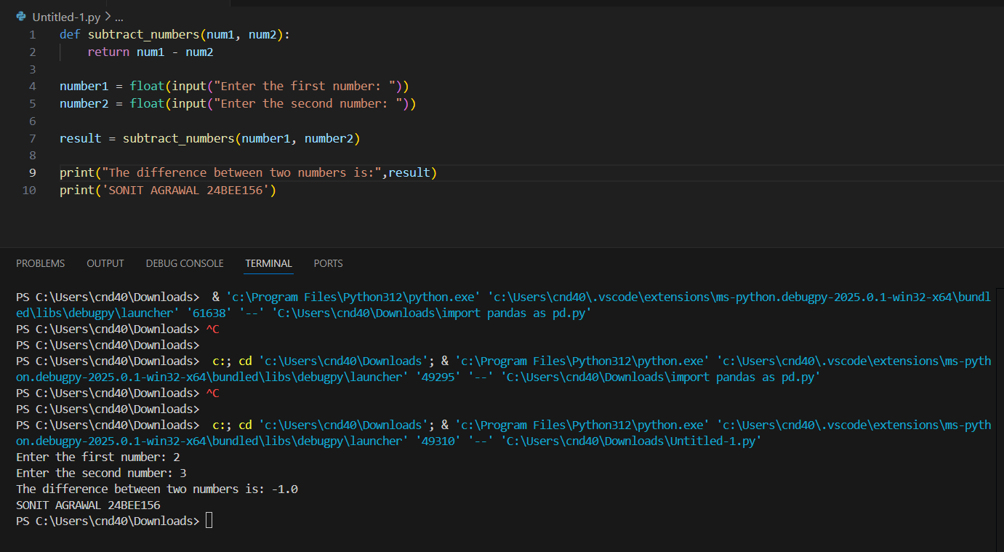

1. Multiply two numbers:

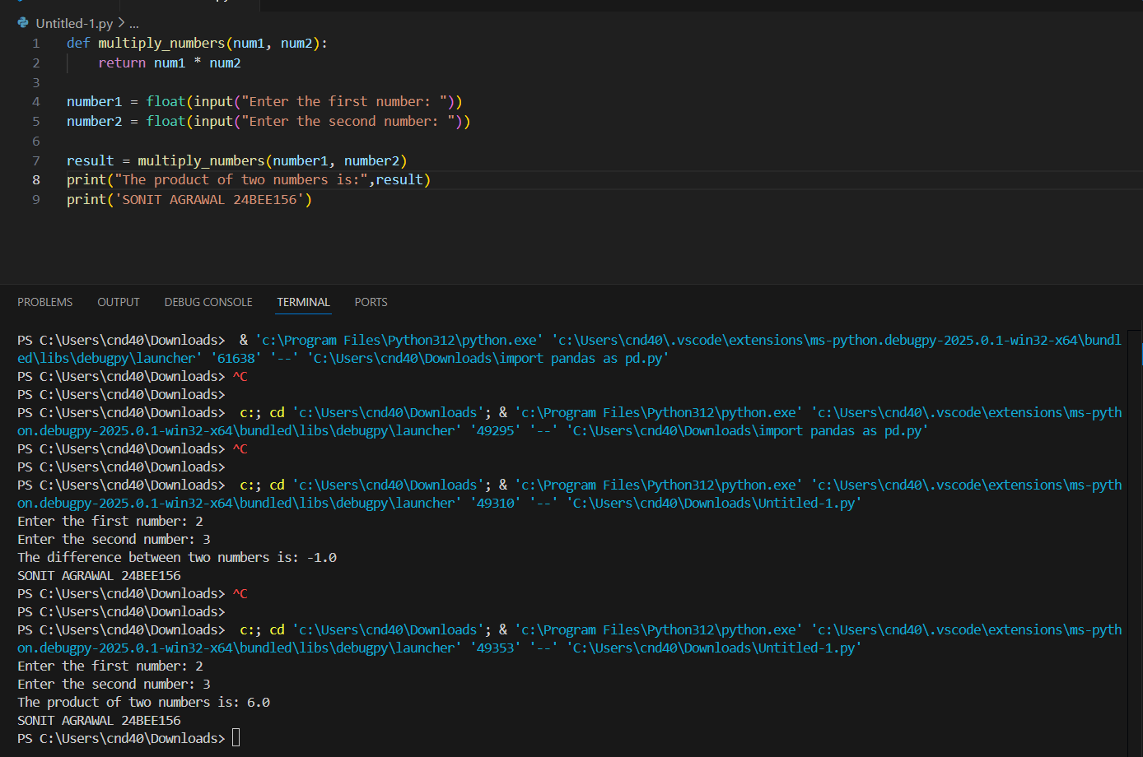

1. Divide two numbers:

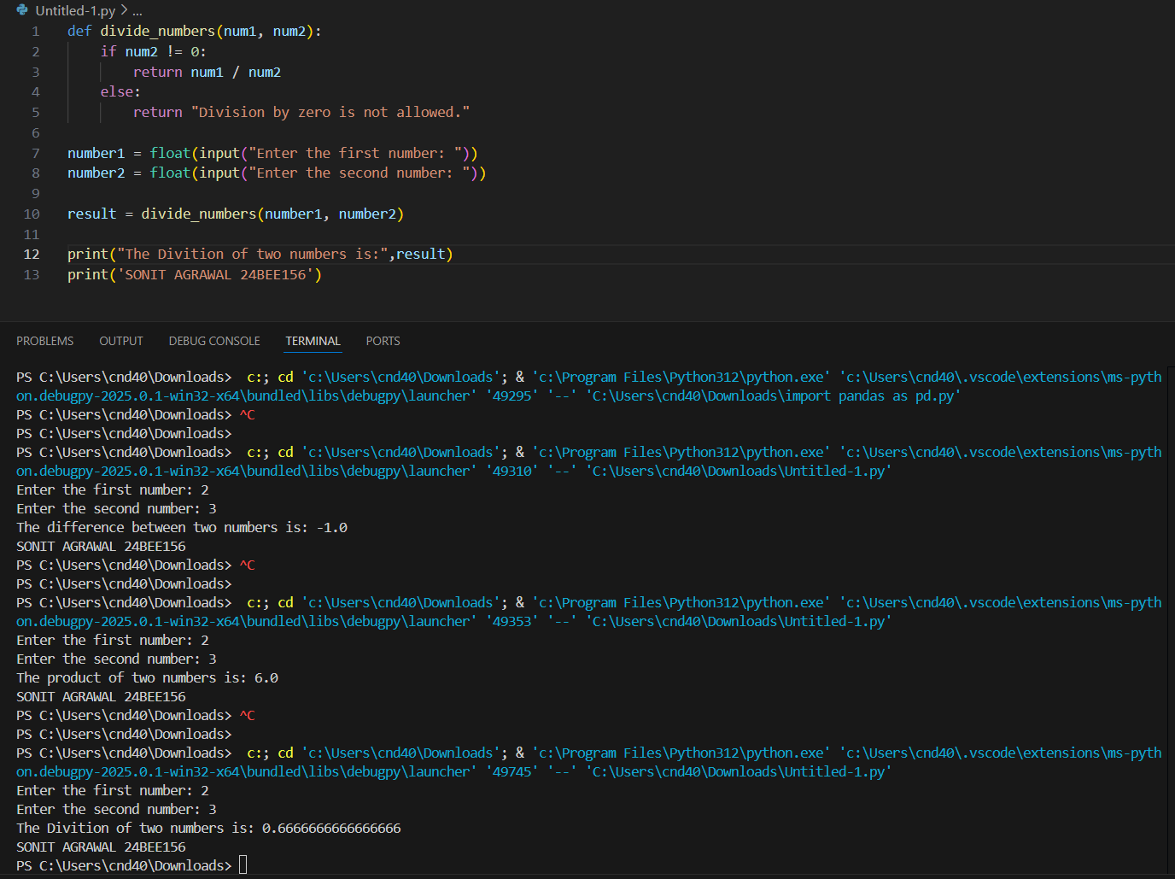

1. Add, multiply, subtract and divide two numbers:

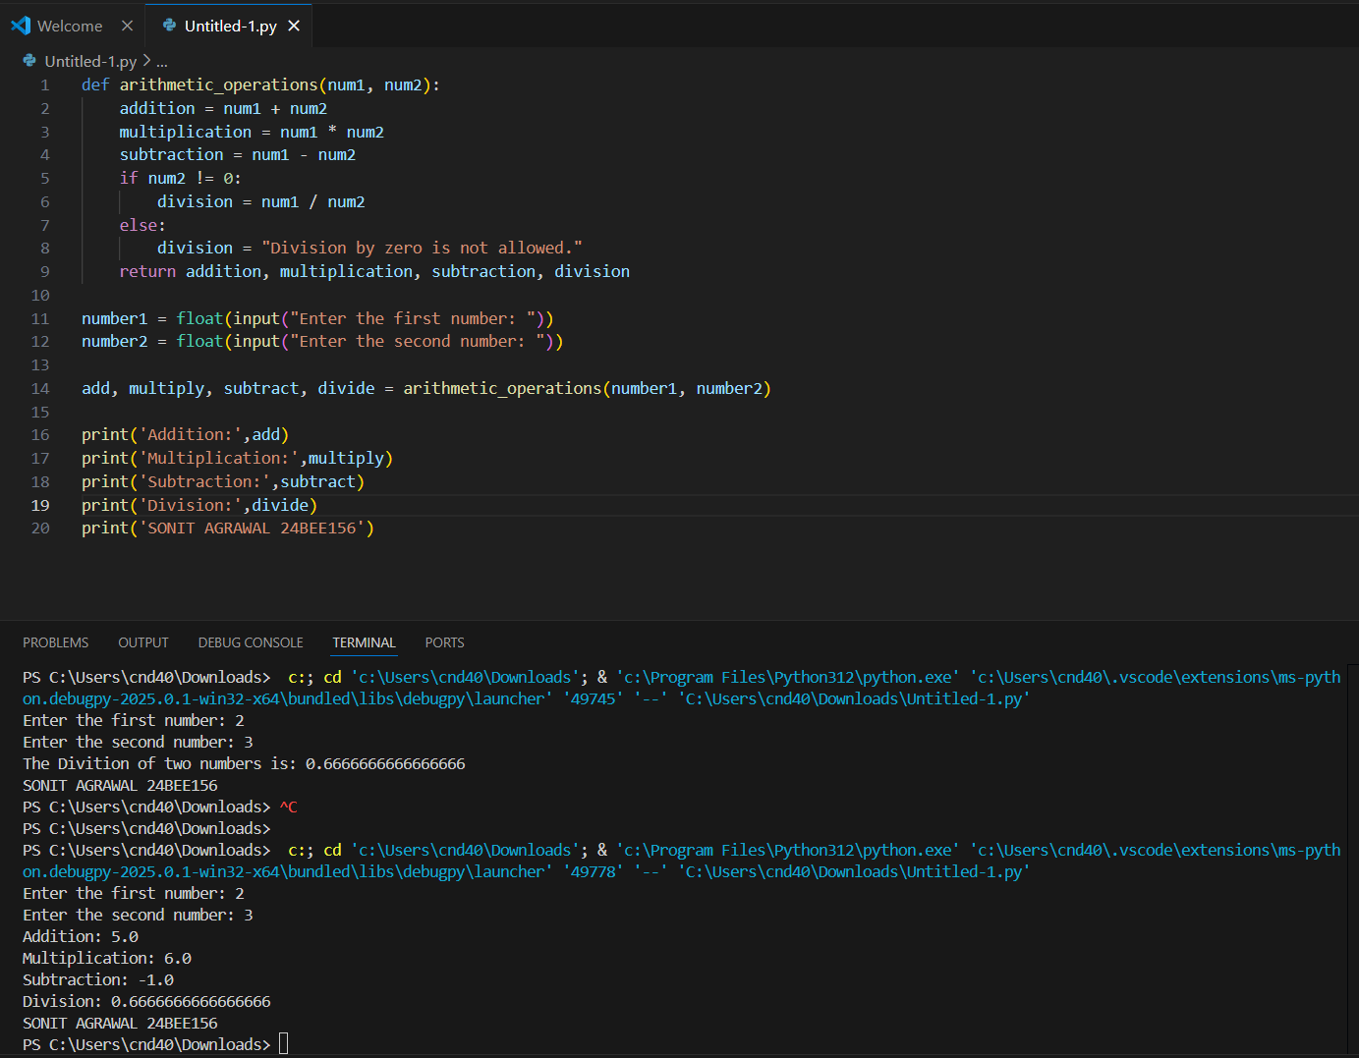

1. Convert hours into minutes:

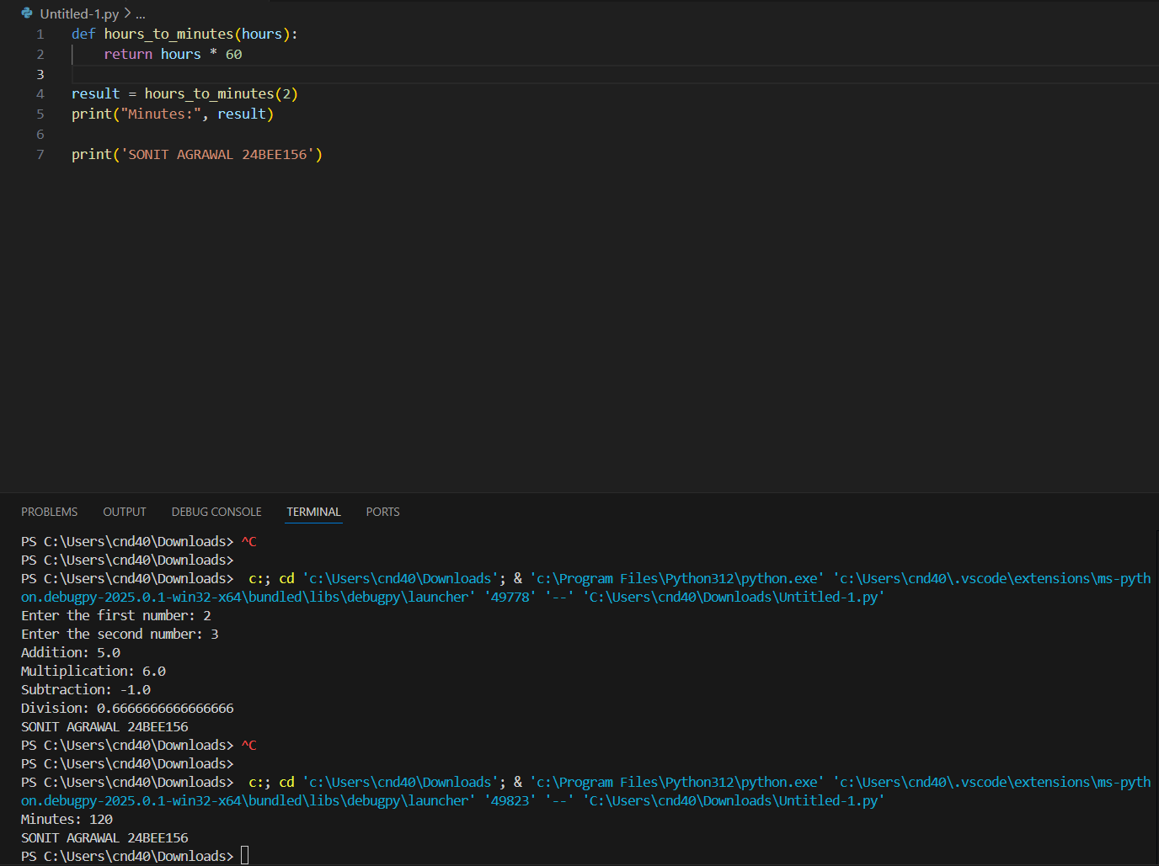

1. Convert minutes into hours:

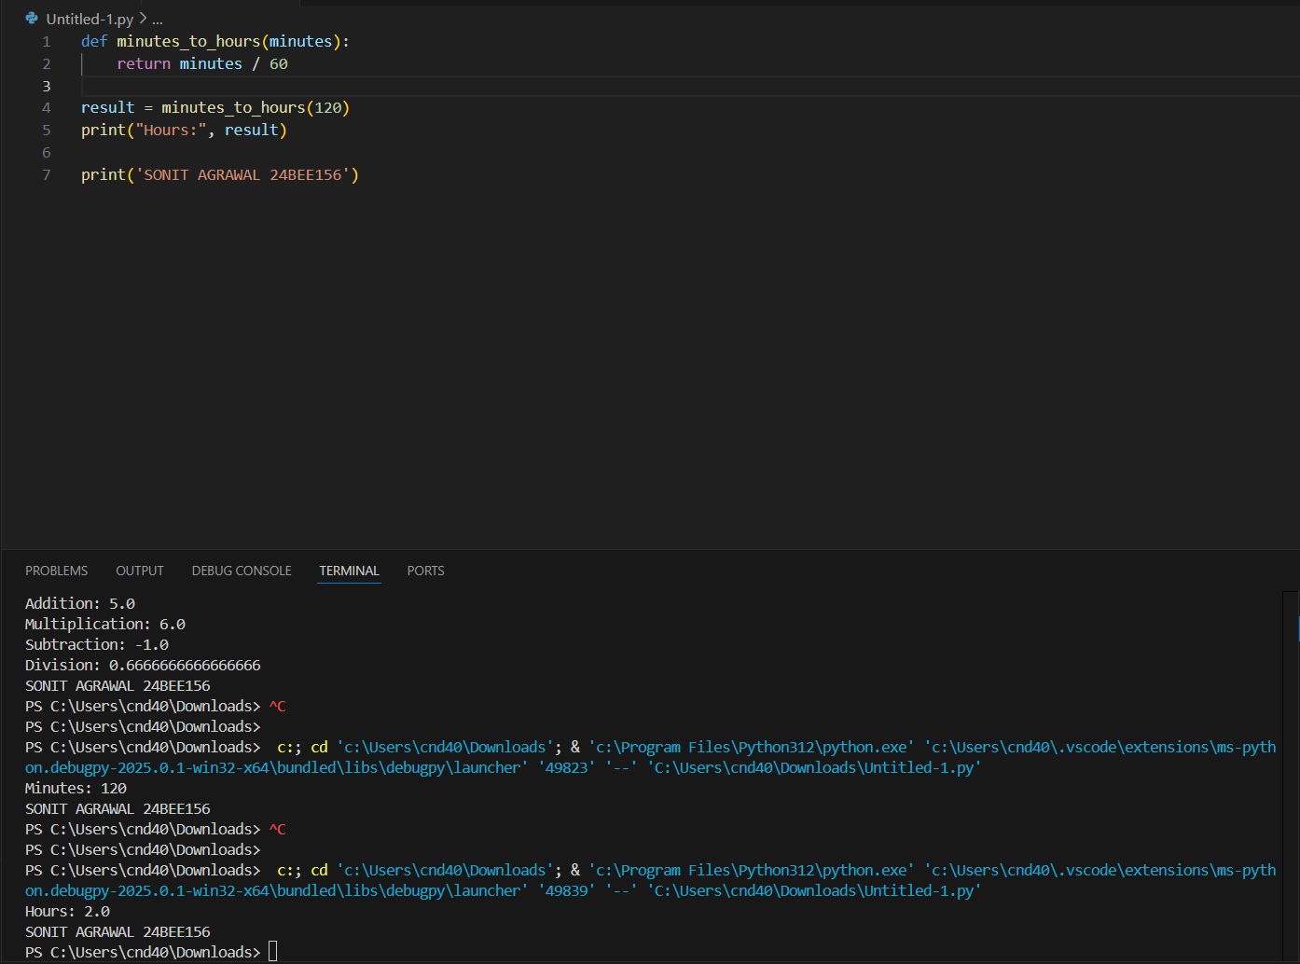

1. Convert dollars into Rs. (1 $ = 85 Rs.):

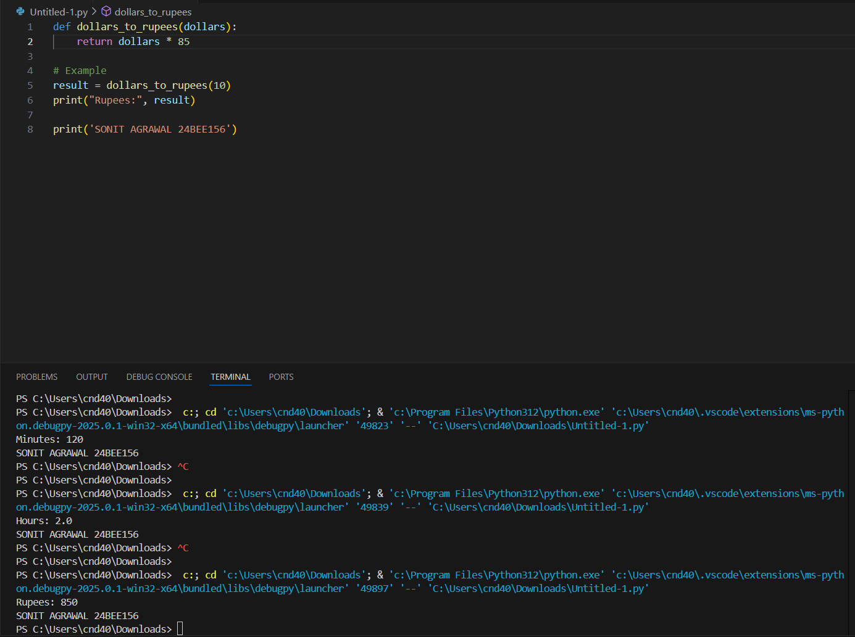

1. Convert Rs. into dollars (1 $ = 85 Rs.):

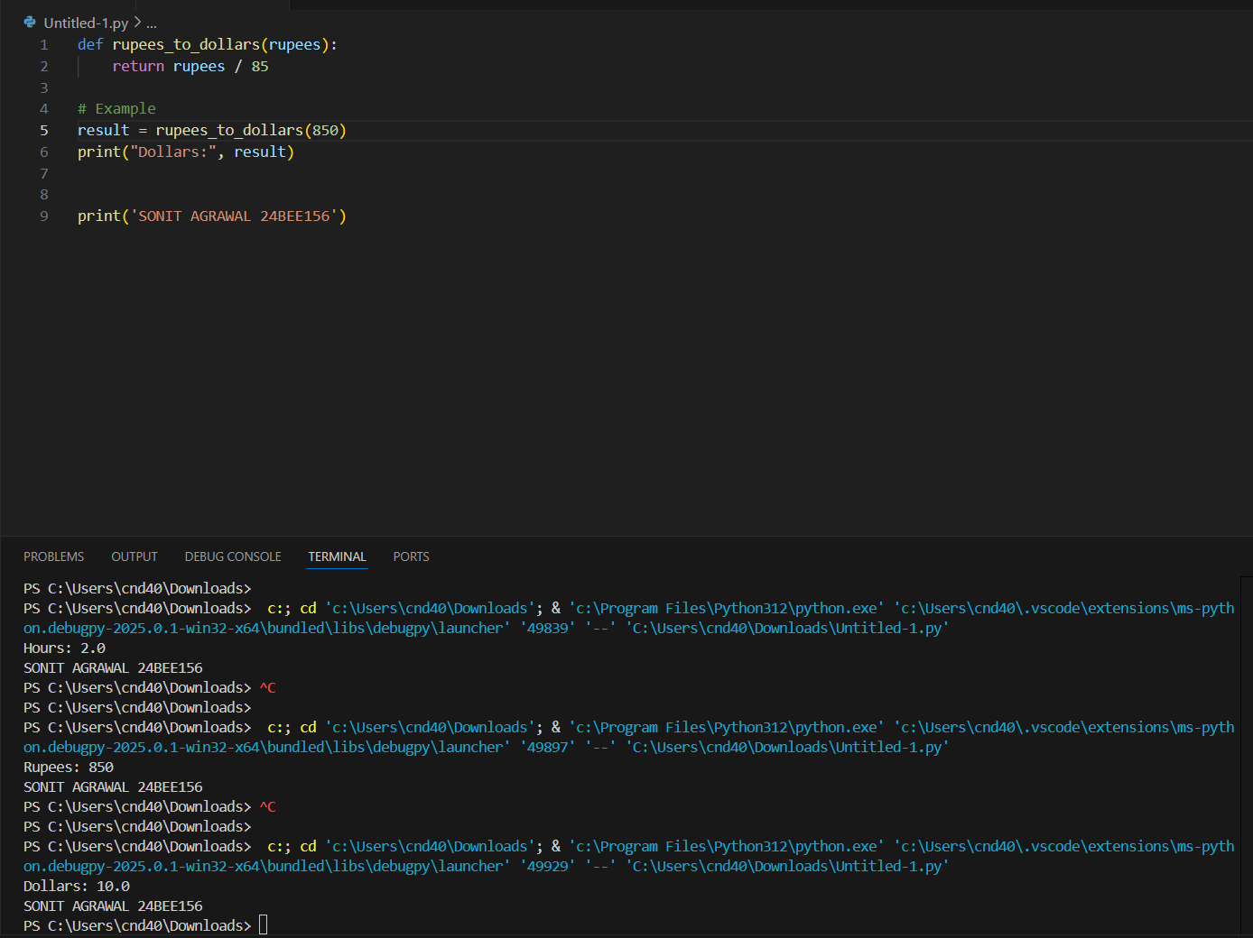

1. Convert dollars into pounds

(1 $ = 85 Rs., 1 pound = 109 Rs.):

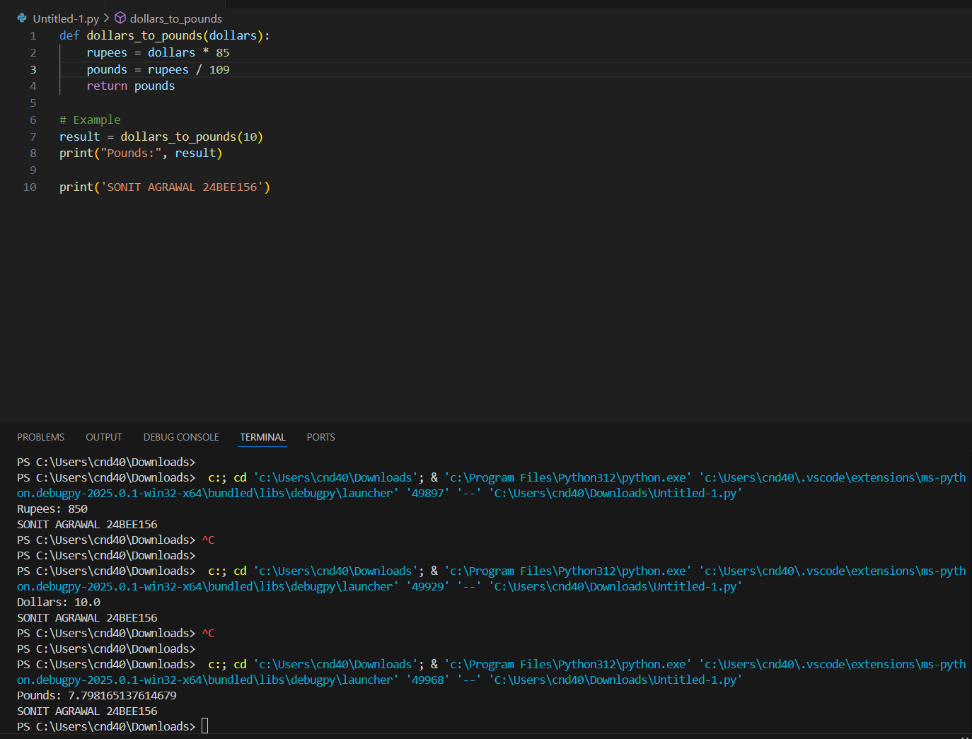

1. Convert grams into kg:

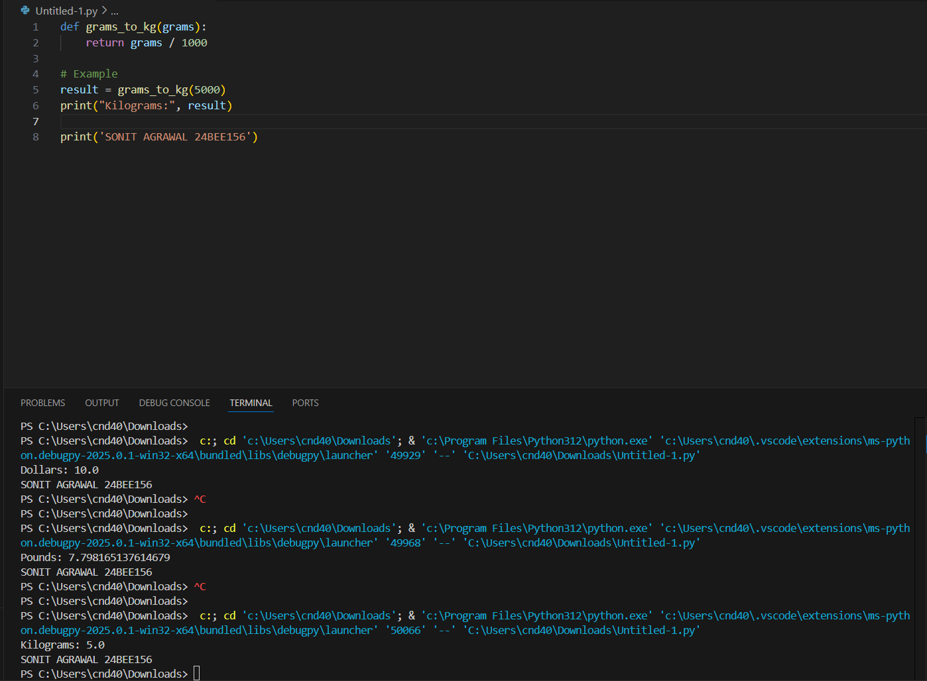

1. Convert kg into grams:

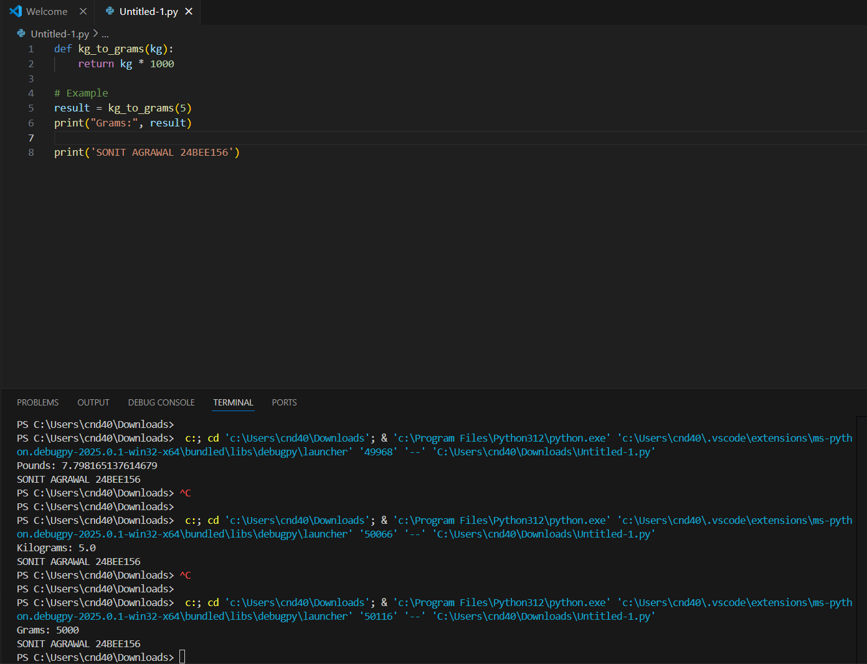

1. Convert bytes into KB, MB, and GB:

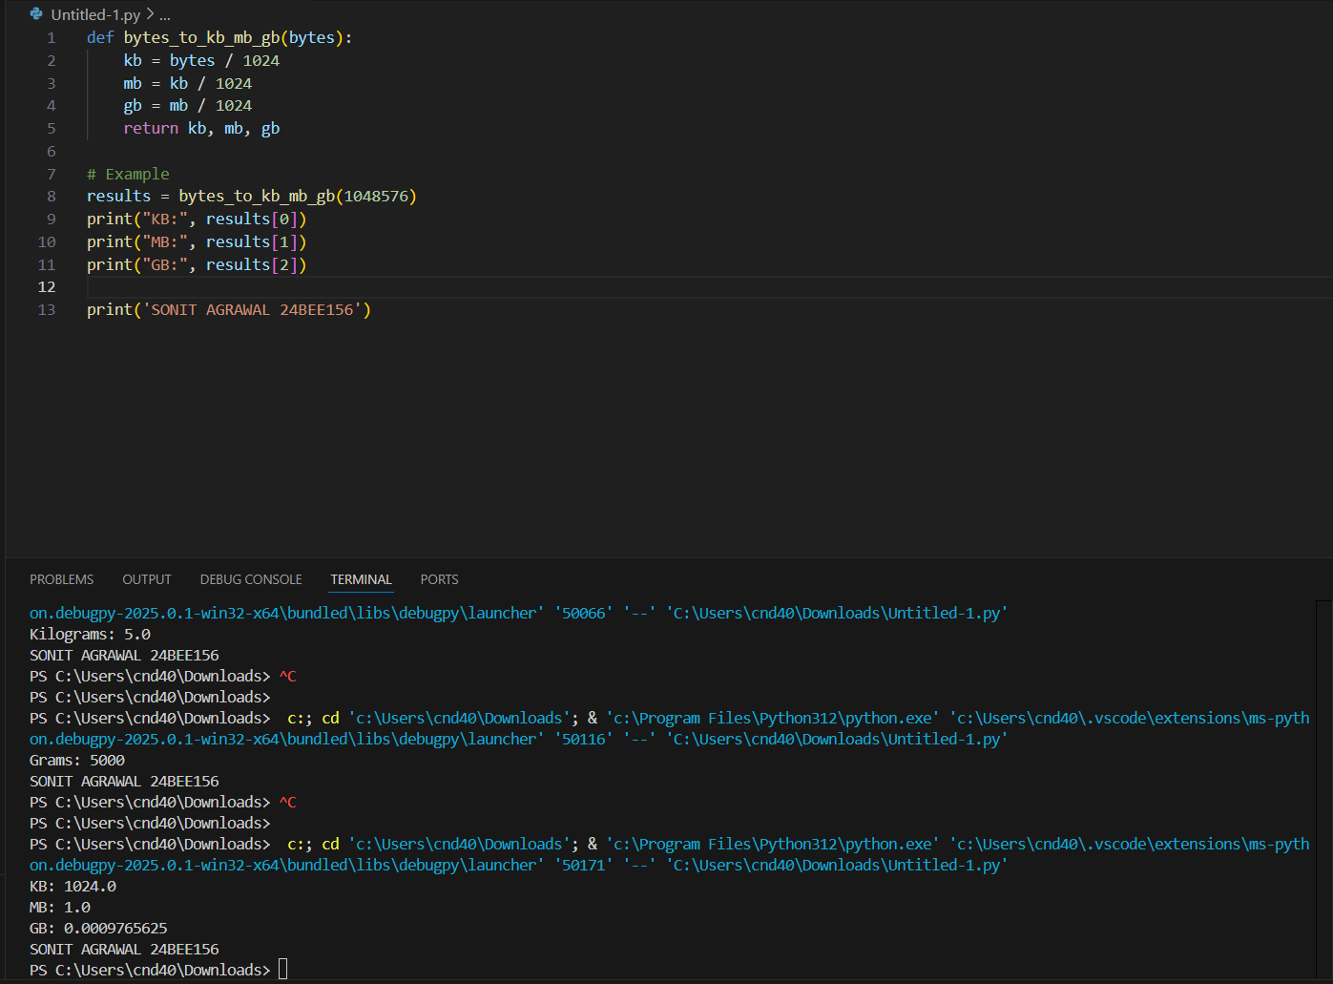

1. Convert Celsius into Fahrenheit:

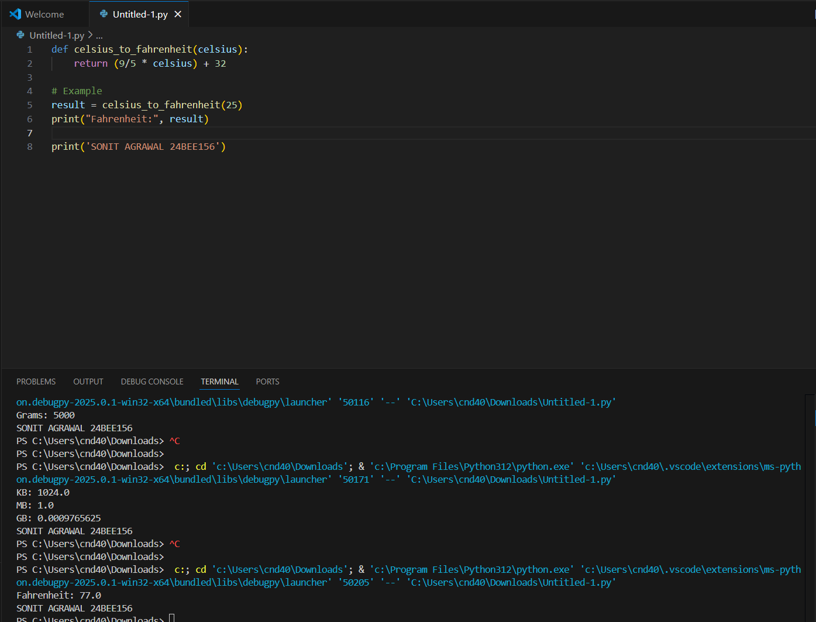

1. Convert Fahrenheit into Celsius:

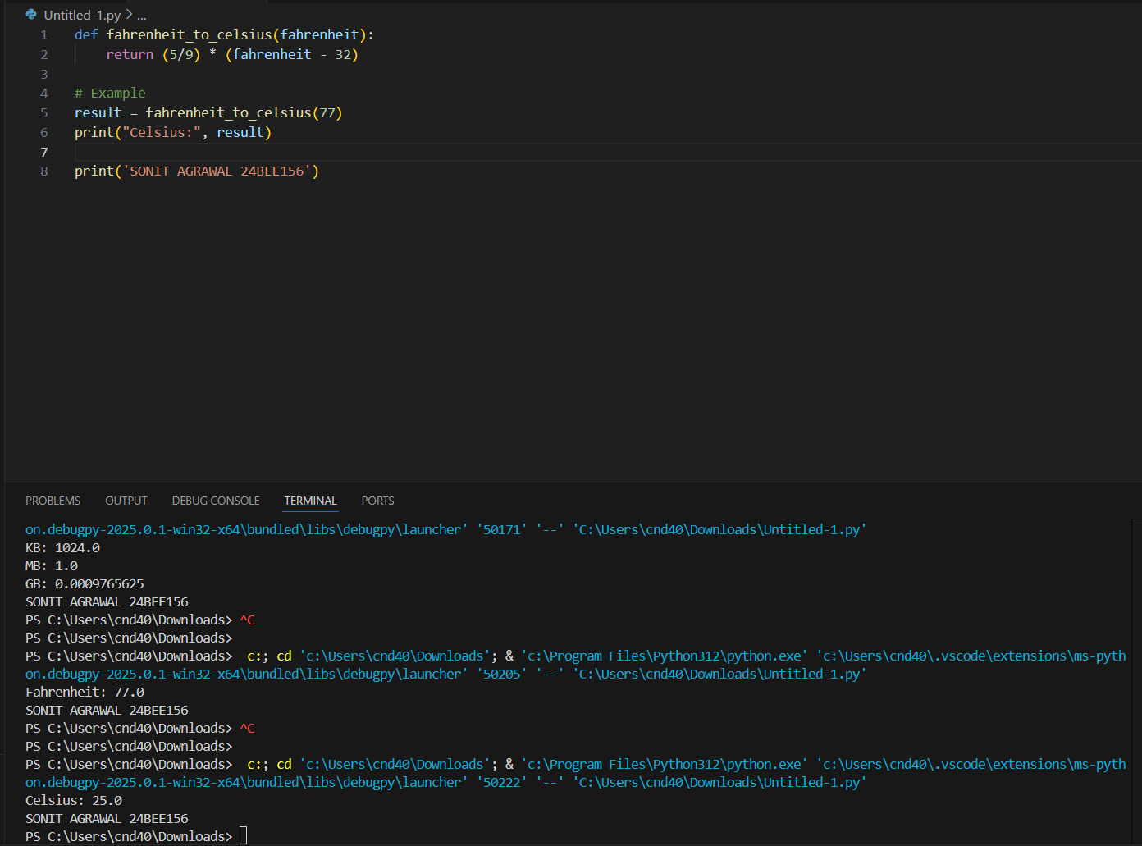

1. **Calculate interest where** I=PRN100I = \frac{PRN}{100}**:**

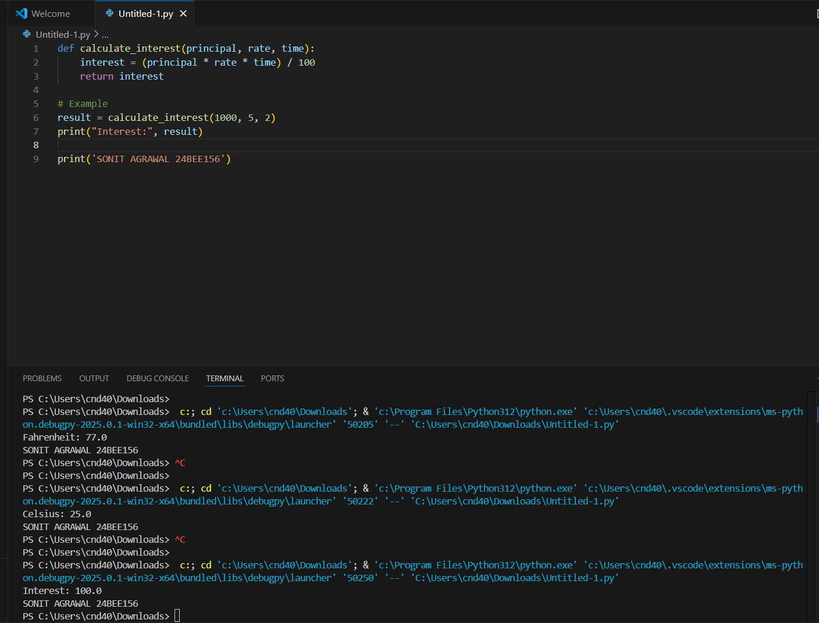

1. **Calculate area & perimeter of a square** A=L2,P=4LA = L^2, P = 4L**:**

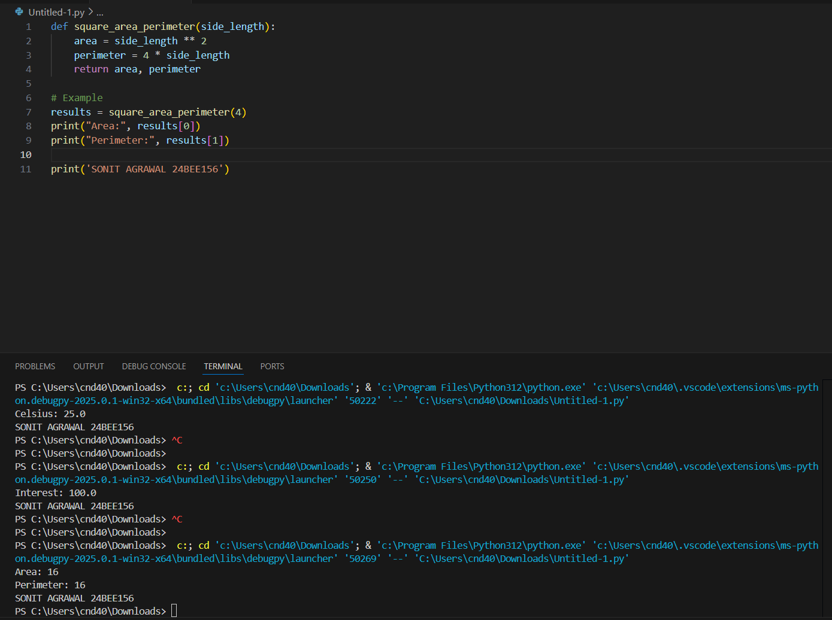

1. **Calculate area & perimeter of a rectangle** A=L×B,P=2(L+B)A = L \times B, P = 2 (L + B)**:**

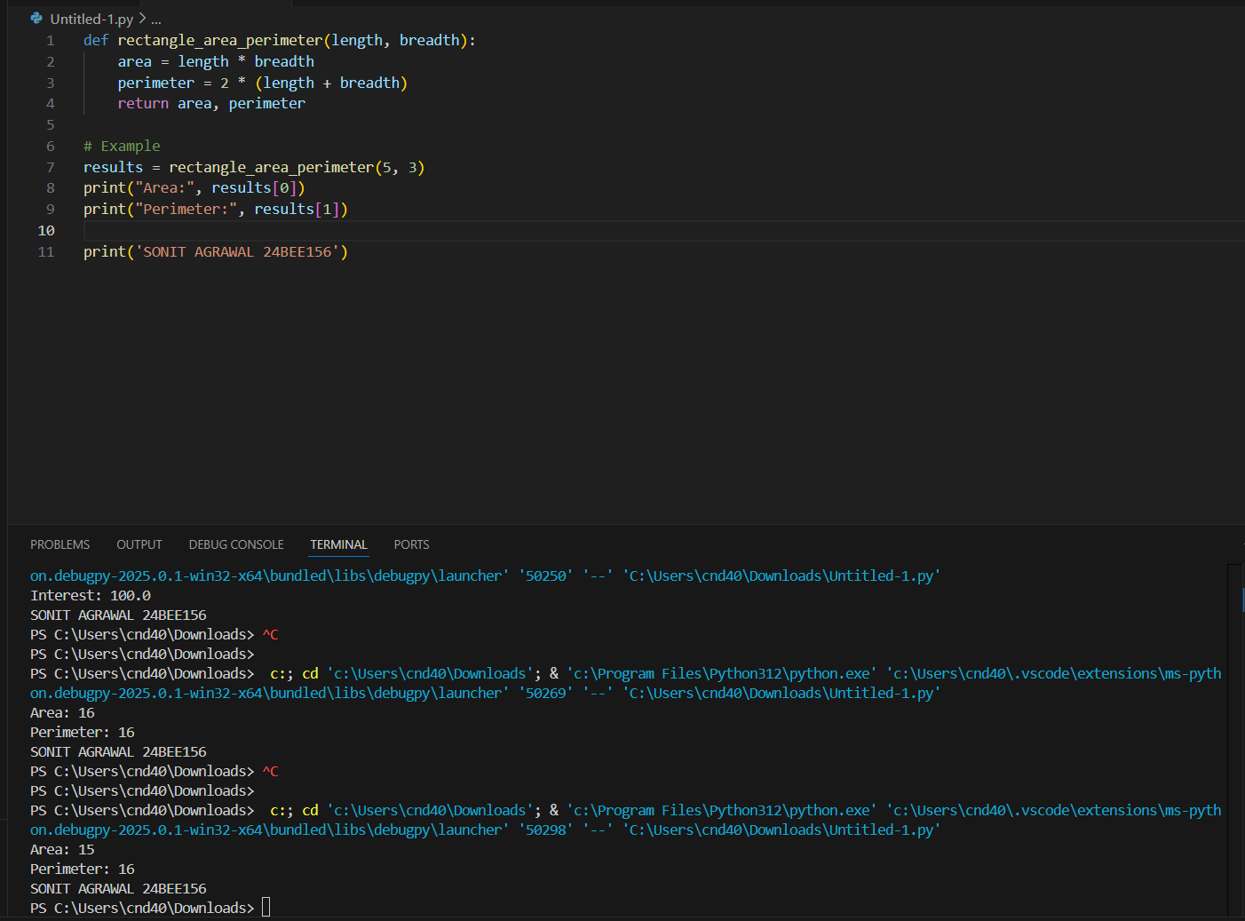

1. **Calculate area of a circle** A=227×R×RA = \frac{22}{7} \times R \times R**:**

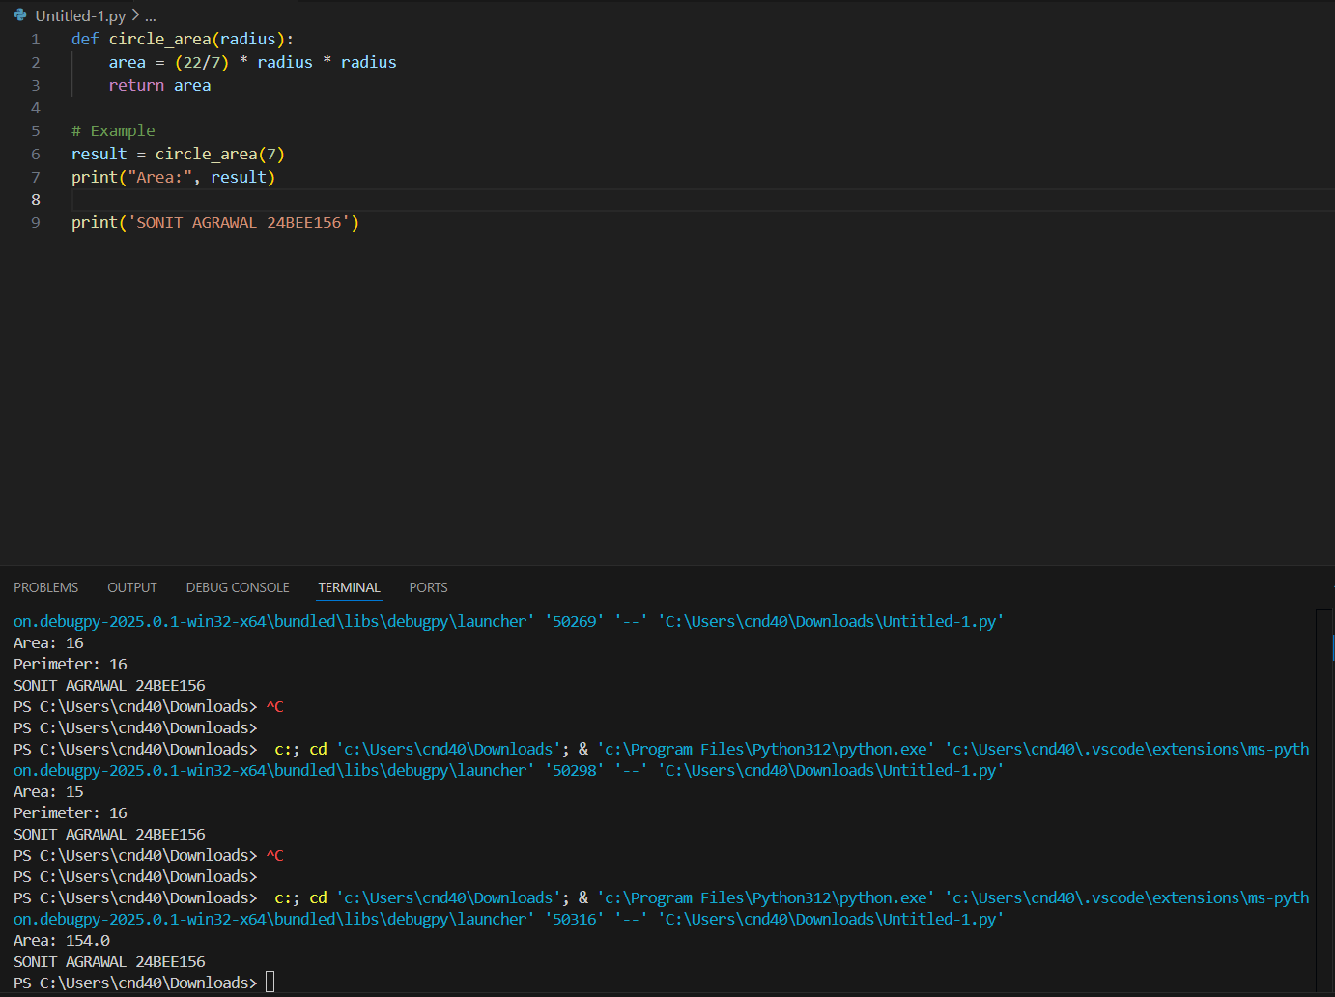

1. **Calculate area of a triangle** A=H×L2A = \frac{H \times L}{2}**:**

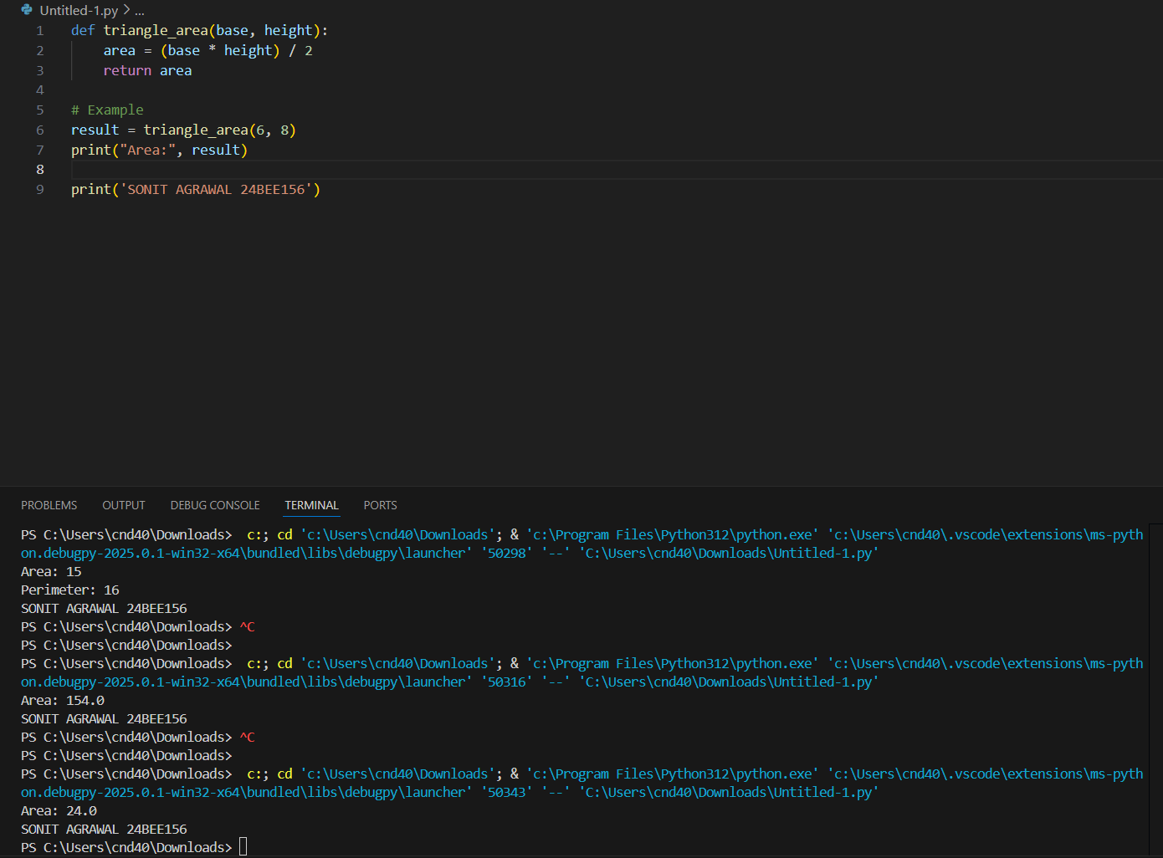

1. Calculate net salary where net salary = gross salary + allowance - deduction. Allowances are 10% while deductions are 3% of gross salary:

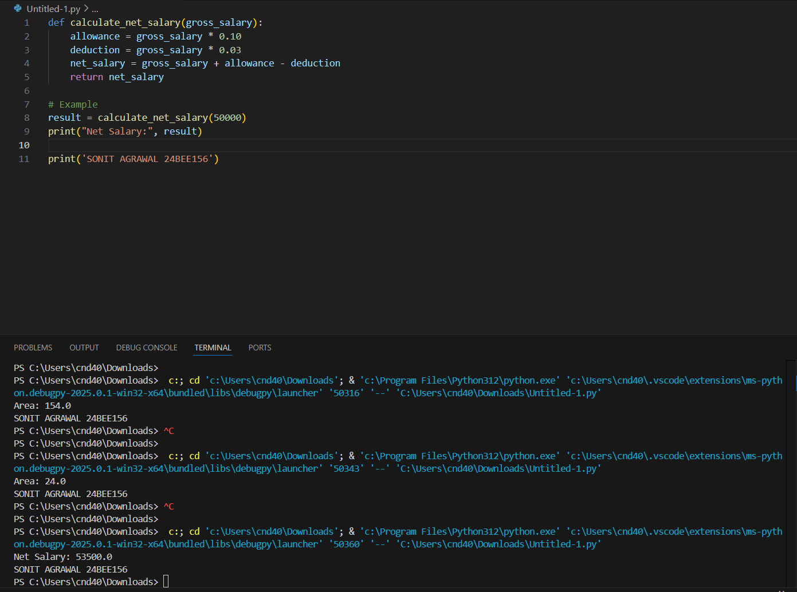

1. Calculate net sales where net sales = gross sales - 10% discount of gross sales:

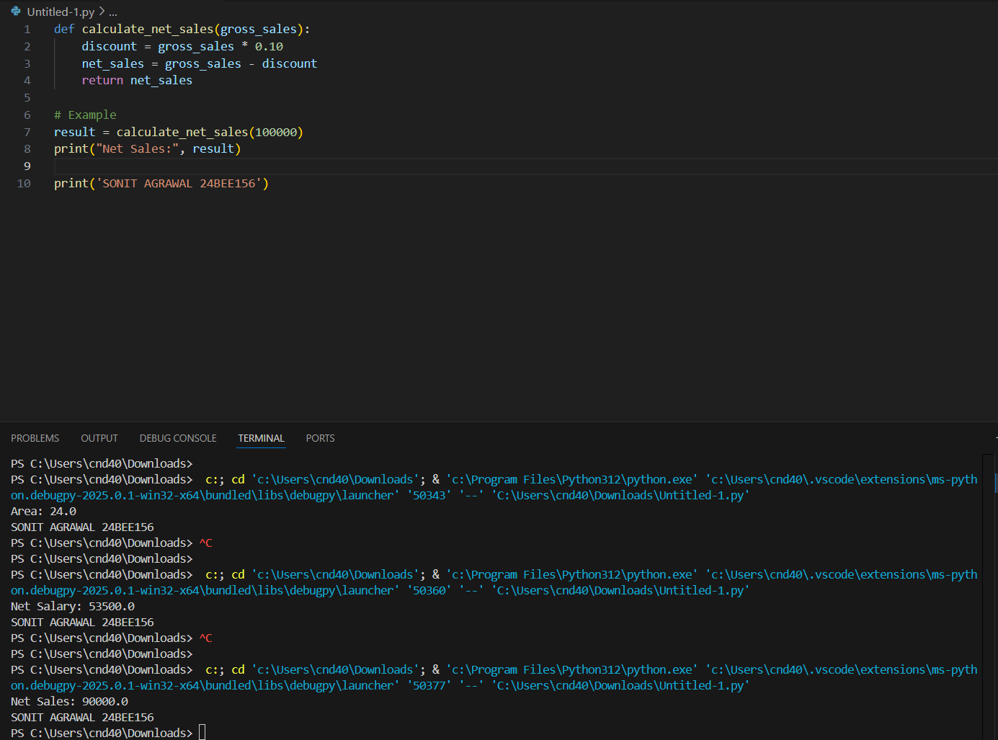

1. Calculate the average of three subjects along with their total:

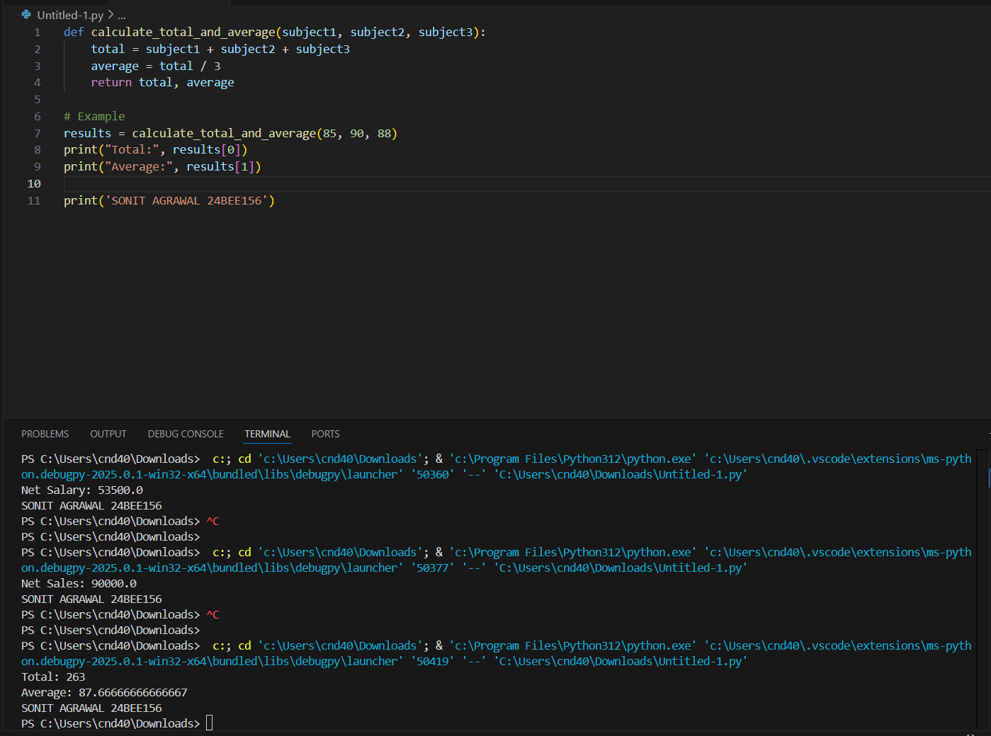

1. Swap two values:

